DATA ANALYSIS INTERNSHIP – DAY 5 REPORT
Organization: Top Tech Developers
Topic Covered: Student Performance Analysis Dataset Expansion & Visualization
On Day 5 of the internship, the Student Performance dataset was further expanded and analyzed by organizing columns based on their relevance for prediction and visualization. In addition, graphical representations were created using CanvasJS to better understand student performance patterns.

1. Expansion of the Dataset (Continuation of Day 2)
The Student Performance Analysis dataset used in previous sessions was further examined and organized. The available columns were categorized into essential, unwanted, and optional columns based on their usefulness for prediction and data visualization.
Available Columns in the Dataset
- id
- first_name
- last_name
- email
- gender
- part_time_job
- absence_days
- extracurricular_activities
- weekly_self_study_hours
- career_aspiration
- math_score
- history_score
- physics_score
- chemistry_score
- biology_score
- english_score
- geography_score
- grade (Output Column)
This dataset contains both personal details and academic performance details of students.

2. Column Separation
To make the dataset more suitable for analysis, the columns were categorized into three groups.
Must Needed Columns
These columns are essential for performance analysis and prediction because they directly influence academic results.
- gender
- absence_days
- weekly_self_study_hours
- math_score
- history_score
- physics_score
- chemistry_score
- biology_score
- english_score
- geography_score
Observation
- These columns directly affect student performance evaluation.
- They are useful for predictive analysis and chart creation.

Unwanted Columns
These columns were removed because they do not contribute to performance prediction.
- first_name
- last_name
- email
Observation
- Personal identification columns are not required for performance prediction.
- Removing unnecessary columns simplifies the dataset.

Optional Columns
These columns provide additional information but are not mandatory for prediction.
- id
- part_time_job
- extracurricular_activities
- career_aspiration
Observation
- Optional columns can be used for additional insights.
- They may support advanced analysis but are not essential for basic prediction.

3. Visualization of the Data
Data visualization was performed to represent student performance in graphical format. Visual representation helps in understanding academic trends more effectively.
Tool Used
- CanvasJS Official Website
CanvasJS was used for creating interactive and responsive charts to analyze the dataset effectively.
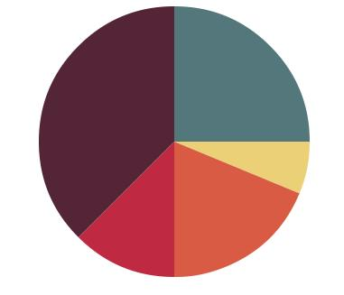
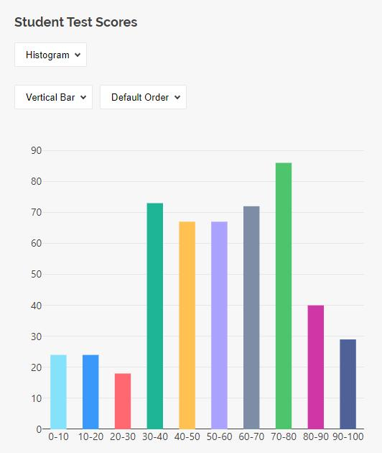
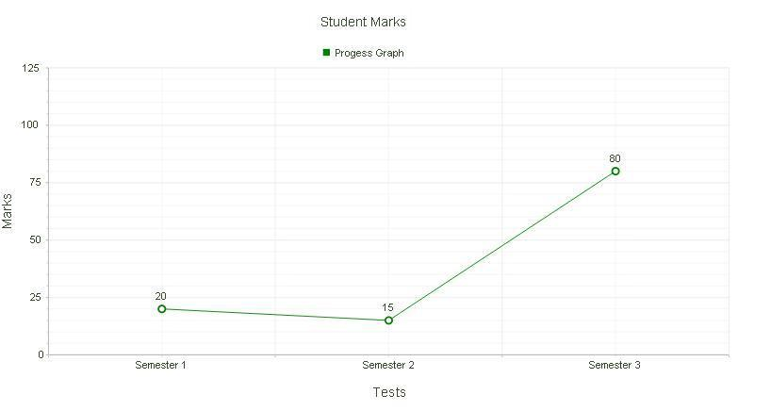
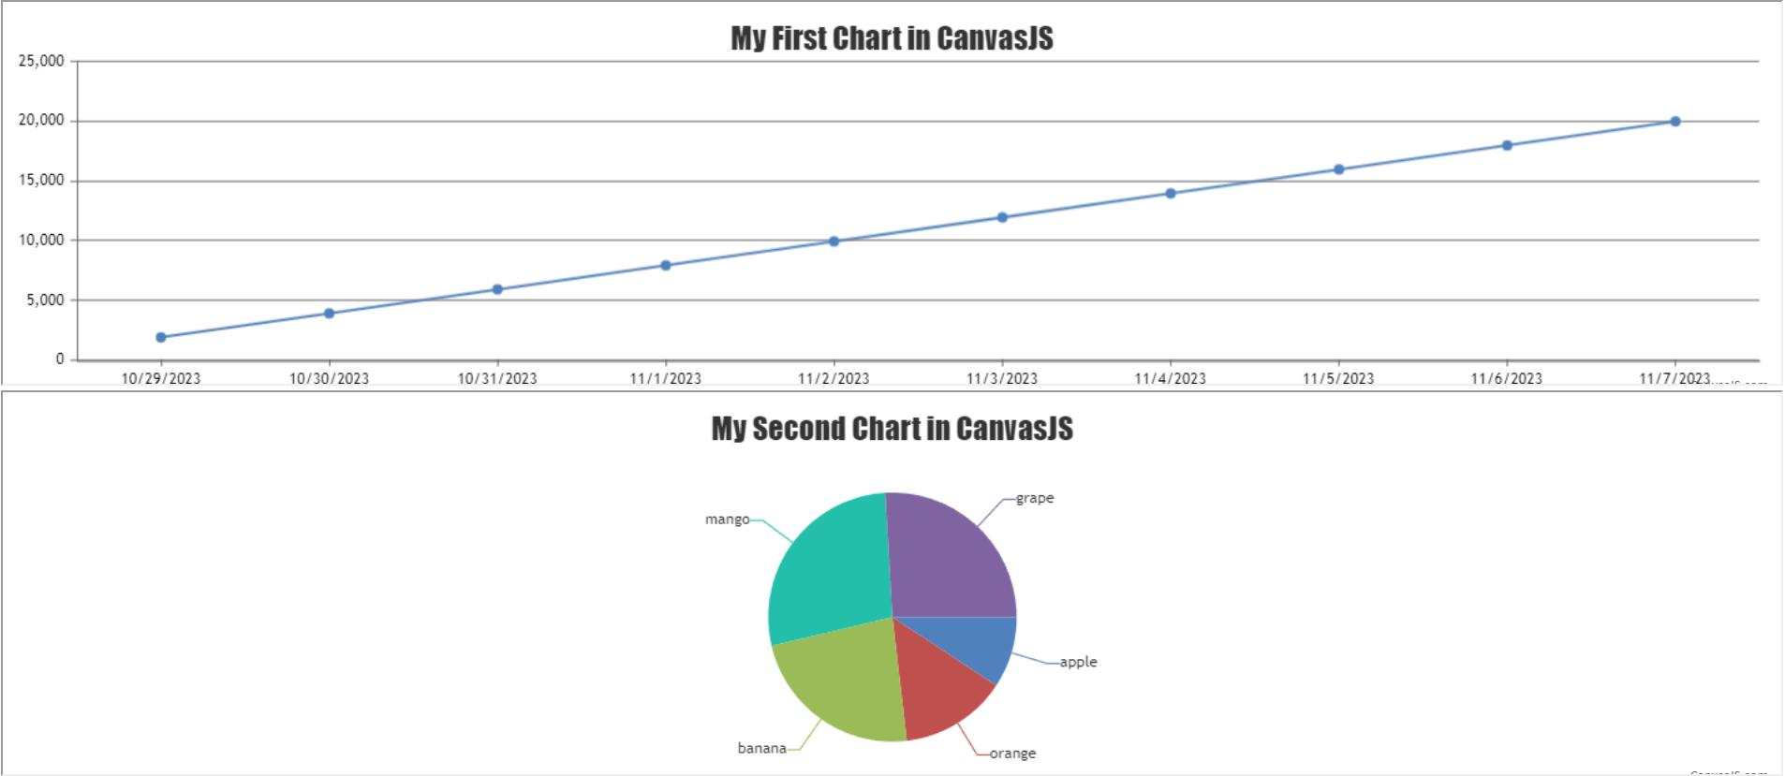
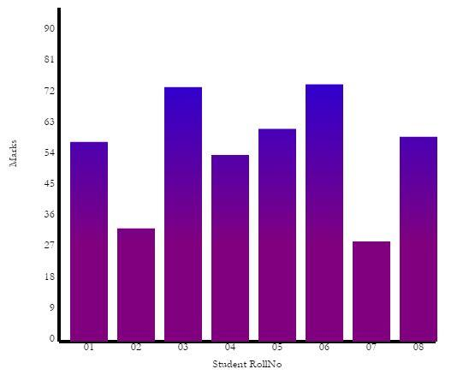
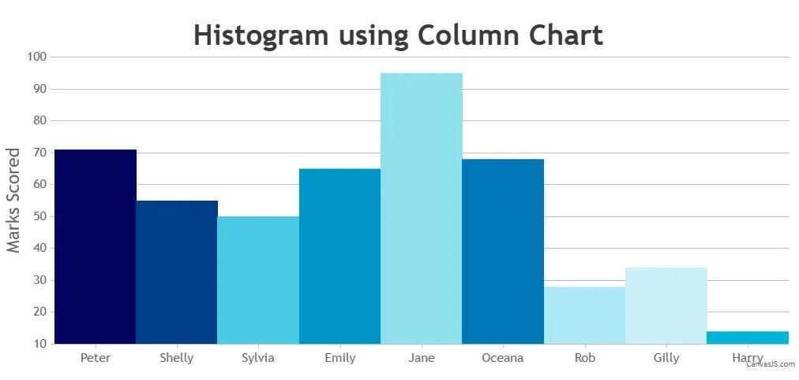

4. Example Charts Created
1. Pie Chart Creation
Objective:
To represent the percentage distribution of student marks in each subject.
Observation
- Pie charts helped in comparing the contribution of subject scores.
- It visually represented performance distribution.

2. Bar Chart Creation
Objective:
To compare average marks based on weekly self-study hours.
Observation
- Bar charts showed the relationship between study hours and academic scores.
- Students with more study hours generally performed better.

3. Line Chart Creation
Objective:
To represent variation in students’ marks based on absence days.
Observation
- Line charts helped in identifying trends between attendance and performance.
- Increased absence days often affected student scores negatively.

5. Google Colab Usage
Google Colab
Google Colab is an online platform used to write and execute Python programs through a web browser. It is widely used for data analysis, machine learning, and visualization tasks.
Uses in Internship
- Executing Python programs
- Performing data analysis
- Creating visualizations
- Testing dataset operations

6. Installing Modules
Required Python modules were installed using the pip install command for performing data analysis and visualization operations.
Modules Used
- Pandas
- NumPy
- Matplotlib
- CanvasJS
Observation
- Installing required modules is necessary before running analysis programs.
- These modules support preprocessing, analysis, and chart creation.

Technologies Used
- Python
- Google Colab
- Pandas
- NumPy
- Matplotlib
- CanvasJS

Learning Outcome
On Day 5, I learned how to expand and categorize dataset columns for effective analysis and prediction.
I understood:
- how to separate important and unwanted columns
- how to identify optional columns for additional analysis
- how to create visual charts using CanvasJS
- how to use Google Colab for executing Python programs
- how to install required modules for data analysis
- how graphical representation improves understanding of datasets

Conclusion
The Day 5 internship session helped me understand how dataset expansion and visualization improve data analysis. I categorized the Student Performance dataset into essential, unwanted, and optional columns based on their importance.
Using CanvasJS, I created pie charts, bar charts, and line charts to analyze student marks, study hours, and attendance patterns. I also learned how to use Google Colab for Python execution and how to install necessary modules for analysis tasks. This session improved my understanding of dataset preparation and graphical analysis techniques.

